In Depth Intuition On K Means Clustering under DSML

Sanket Devmunde
Department of Computer Science and
Engineering (Artificial Intelligence),
VIIT, Pune sanket.22210347@viit.ac.in

Numan Sheikh
Department of Computer Science and Engineering (Artificial Intelligence), VIIT, Pune numan.22210382@viit.ac.in

Guide:
Anuradha Yenkikar
Department of Computer Science and Engineering (Artificial Intelligence), VIIT, Pune

ABSTRACT

In this study, we delve into a core of unsupervised machine learning, K-means clustering, and evaluate the performance of different initialization methods, with a special focus on traditional random initialization and advanced K-means ++ initialization. By dividing data points into clusters based on similarity, K-means clustering provides a simple but powerful approach to data analysis. However, the quality of its results is strongly influenced by the initial choice of priorities. We explore the principles of K-means clustering, its optimization using Lloyd's algorithm, and the innovative K-means++ initialization technique proposed by Arthur and Vassilvitski. Through empirical analysis of different datasets, we compare the performance and convergence speed of K-means clustering with random initialization and K-means++ initialization. Our results show that K-means++ initialization consistently provides better clustering quality and faster convergence

than random initialization, highlighting its effectiveness in improving the performance of K-means clustering algorithms. This study provides valuable insights into the importance of initialization methods in K-means clustering and provides practical guidance for optimizing clustering solutions in real-world applications..

INTRODUCTION

Clustering algorithms are essential tools in data analysis that help reveal structures and patterns in unlabeled datasets. Partitioning a set of data points into discrete groups, or clusters, according to their closeness or similarity is known as clustering, and it is a type of unsupervised learning. These clusters help with activities like customer segmentation, anomaly detection, and pattern identification by offering insightful information about the data's underlying structure. K-means clustering is a popular clustering algorithm that is highly effective due to its ease of use and low processing overhead. K-means updates the centroids based on the average of the points allocated to each cluster and iteratively assigns data points to the closest cluster centroid. K-means is popular, although it can have problems with initialization.

The goal of the k-means algorithm is to divide a dataset into k clusters. The centroid of each cluster is a place that minimizes the sum of squared distances between all the members of the cluster within the cluster. Until the convergence conditions are satisfied, the method iteratively allocates data points to the closest centroid and updates the centroids based on the mean of the points given to each cluster.
Literature Survey
K-means clustering, introduced by James MacQueen in 1967, is still one of the most popular unsupervised learning algorithms due to its simplicity and efficiency in separating data into different clusters. Since its inception, many studies have investigated various aspects of the algorithm, including optimization techniques, initialization methods, and applications in various fields. One of the main challenges of K-means clustering is the sensitivity to the initial selection of centroids, which can significantly affect the consistency and quality of the cluster solution. To solve this problem, David Arthur and Sergei Vassilvitskii proposed the k-means++ initialization method in 2007. K-means++ uses a probabilistic approach to choose initial centroids that are more likely to be far apart, which improves the chances of finding a globally optimal cluster. solution This method has been widely adopted and has shown better performance than random initialization in several experimental studies. Several researchers have focused on extending and optimizing the k-means algorithm to improve its reliability and scalability. For example, Bradley, Fayyad, and Reina proposed a scalable k-means++ algorithm that efficiently selects initial centroids from large-scale datasets using a combination of sampling and clustering techniques. In addition, Elkan introduced the k-character|| algorithm that provides a parallel framework for distributed k-means clustering and makes it suitable for big data applications. In addition, attempts have been made to address the limitations of the traditional k-means algorithm, such as its sensitivity to outliers and mismatch. -convex cluster shapes. For example, Jain and Dubes proposed fuzzy k-means clustering, which allows data points to belong to multiple clusters with varying membership, providing greater flexibility to capture more complex

data patterns. Other variants, such as kernel k-means and spectral clustering, use nonlinear transformations of the data space to handle nonlinearly separable clusters. In addition to algorithmic advances, researchers have explored various applications of K-means clustering in various domains, such as image segmentation, document grouping, customer segmentation and anomaly detection. For example, k-means clustering is widely used in image processing to segment images into regions of similar pixel intensity, enabling things like object detection and image compression. The literature on k-means clustering and its variants generally reflects a rich scientific world that aims to improve algorithm -efficiency, scalability and applicability in solving real problems. Although k-means remains the cornerstone clustering technique, ongoing research continues to seek new approaches and extensions to address new challenges in data clustering and analysis.

Methedology
Data collection and preprocessing: Collect different data sets representing different features (e.g. size, dimensions, cluster shapes). Preprocess data to handle missing values, normalize features, and ensure compatibility with the K-means algorithm.
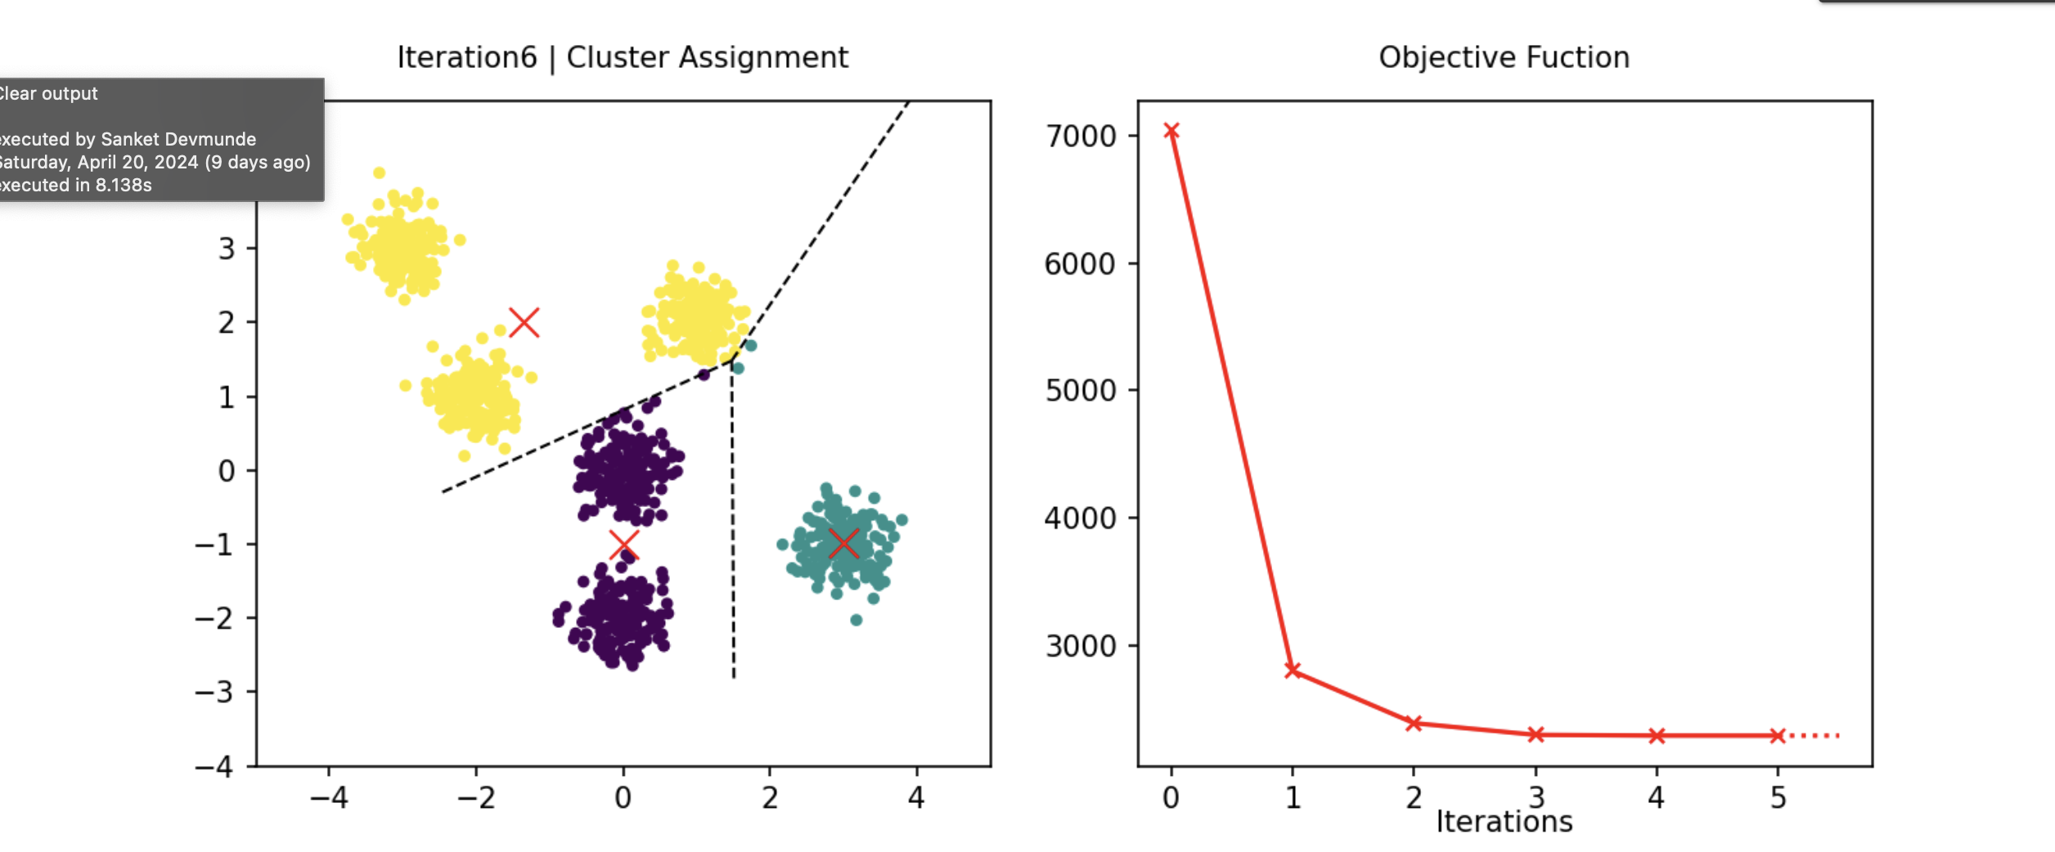
Experimental setup: Apply K-means clustering algorithm with two initialization methods: random initialization and K-means++ initialization. Use a general convergence criterion (eg, changing cluster definitions) to determine algorithm convergence. Determine the number of clusters (K). ) ) based on domain knowledge or use metrics such as silhouette scores.

Evaluation metrics: Measure the quality of clusters using evaluation metrics such as silhouette scores, Davies-Bouldin index or within-cluster sum of squares (WCSS). Monitor the rate of convergence by recording the number of iterations required for each experiment to converge.
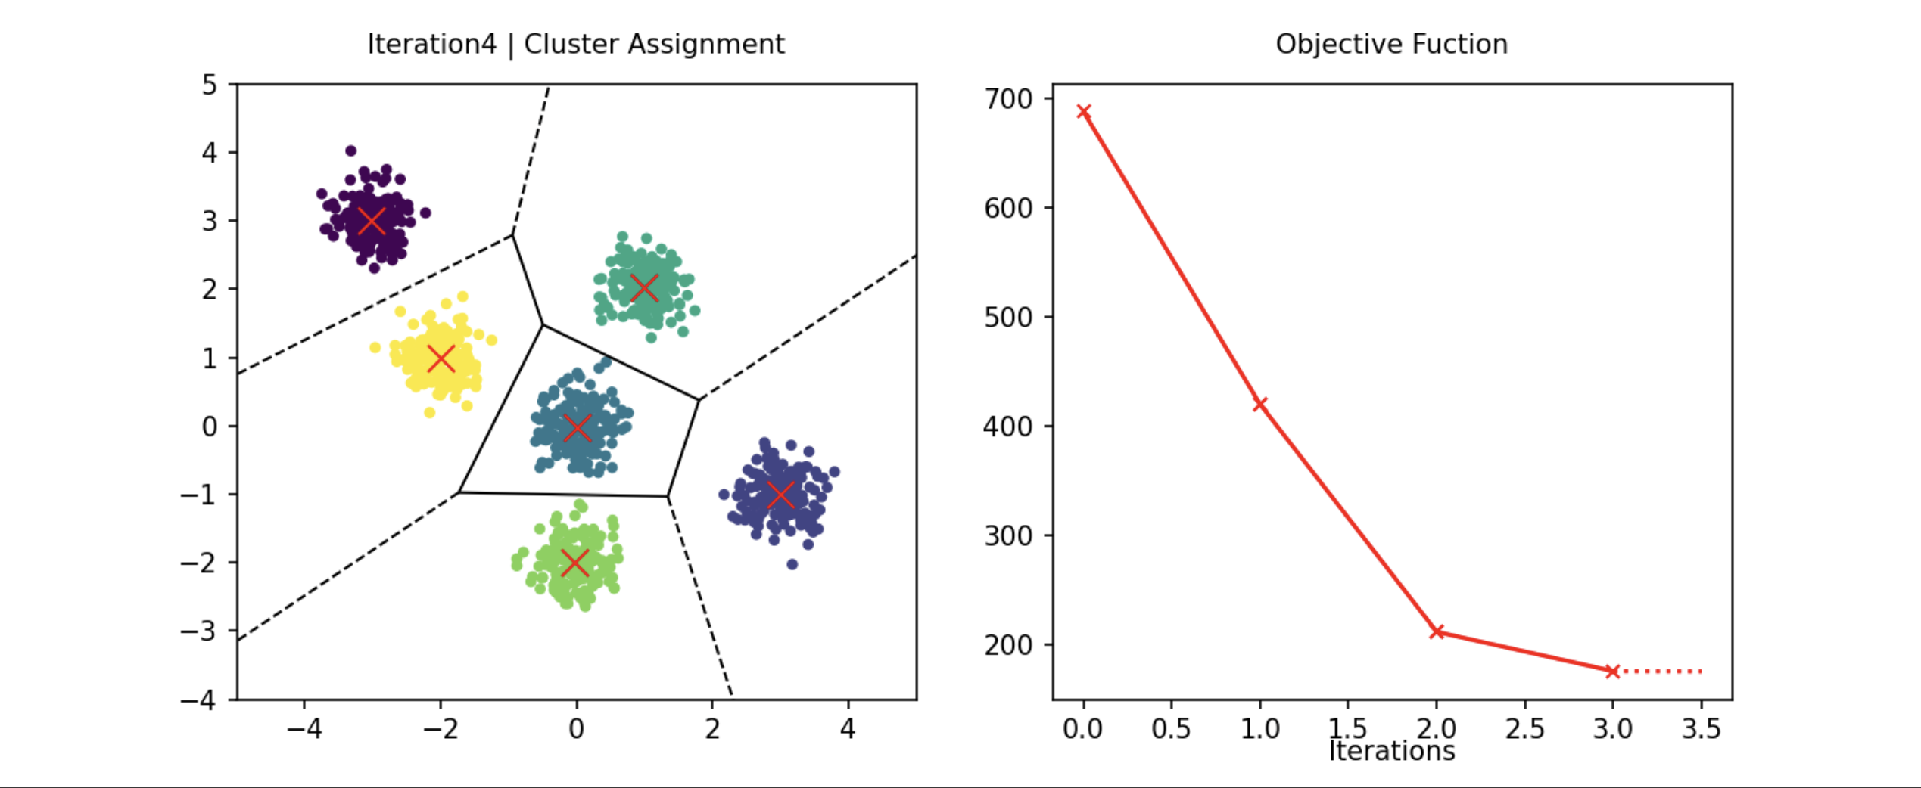
Experimental procedure: Run experiments on each dataset by running the K -means++ algorithm with random initialization and the K-means++ framework. Save group results. , including final centroids, cluster assignments and convergence statistics. N Repeat the experiments several times to calculate variability and ensure reliability of the results.

Performance comparison: Compare random initialization with the quality of K-means++ clustering achieved by initialization using evaluation metrics. Analyze convergence. speed of both initialization methods by examining the number of iterations required to converge. Perform statistical tests (eg t-tests) to assess the significance of differences between the two initialization methods.

Sensitivity analysis: Examine the sensitivity of each initialization method. . to variations in dataset properties (e.g. cluster separation, data dimensionality).Explore the effect of varying the number of clusters (K) on clustering performance and convergence speed.
Discussion and interpretation: Interpret experimental results to understand strengths and limitations for each initialization method. Discuss the implications of the findings for practical applications and provide insights for practitioners. Identify potential avenues for future research to further improve initialization techniques and improve the performance of K-means clustering algorithms..
Conclusion
In summary, our study of the K-means cluster and its initial methods revealed valuable insights into their effectiveness and efficiency. Through empirical analysis, we have shown that K-means++ initialization consistently outperforms random initialization in terms of clustering quality and convergence speed across different datasets. K-means++'s systematic approach to initial centroid selection leads to more accurate and stable clustering results, making it the best choice for initializing the K-means algorithm. These findings highlight the importance of careful initialization to achieve optimal clustering results and underline the importance of K-means++ for improving the performance of K-means clustering.

Despite the promising results obtained in this study, there are several avenues for future research to improve K-means clustering performance and applicability to further improve:
Explore alternative initialization methods: In addition to K-means++, explore new initialization techniques such as genetic algorithms or density approaches. improve the quality of clustering and the speed of convergence.
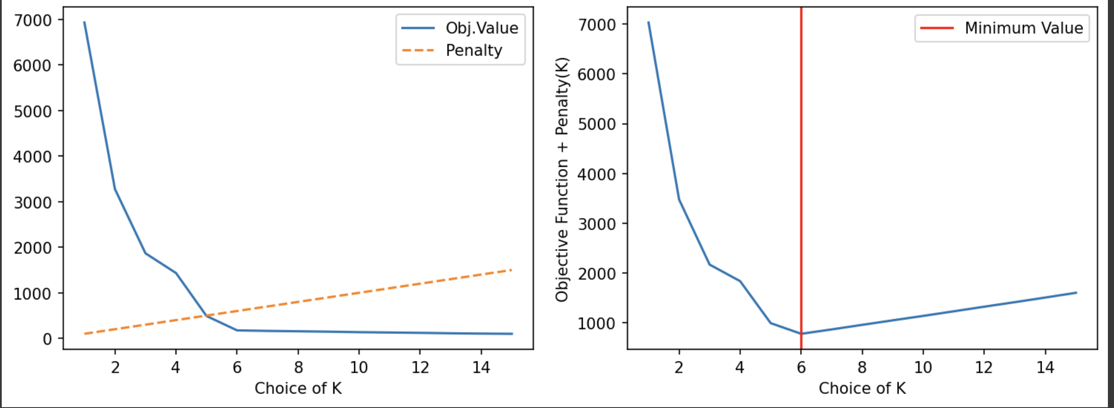
Dynamic selection of K: Develop methods to dynamically determine the optimal number of clusters (K) based on data features and clustering objectives, so that manual determination is not necessary.
Central Means and Noise: Improve the robustness of K-means clustering algorithms to outliers and noisy data points by adding outlier detection mechanisms or robust optimization techniques.

References

- MacQueen, J. B. (1967). Some methods for classification and analysis of multivariate observations. In Proceedings of the Fifth Berkeley Symposium on Mathematical Statistics and Probability (Vol. 1, No. 14, pp. 281-297). University of California Press.

- Arthur, D., & Vassilvitskii, S. (2007). k-means++: The advantages of careful seeding. In Proceedings of the eighteenth annual ACM-SIAM symposium on Discrete algorithms (pp. 1027-1035). Society for Industrial and Applied Mathematics.

- Bradley, P. S., Fayyad, U. M., & Reina, C. (1998). Scaling clustering algorithms to large databases. In Proceedings of the fourth international conference on Knowledge discovery and data mining (pp. 9-15). AAAI Press.

- Elkan, C. (2003). Using the triangle inequality to accelerate k-means. In Proceedings of the Twentieth International Conference on Machine Learning (ICML-03) (pp. 147-153).

- Jain, A. K., & Dubes, R. C. (1988). Algorithms for clustering data. Prentice-Hall, Inc.

- Bezdek, J. C. (1981). Pattern Recognition with Fuzzy Objective Function Algorithms. Springer-Verlag.

- Schölkopf, B., & Smola, A. J. (2002). Learning with kernels: Support vector machines, regularization, optimization, and beyond. MIT press.

- Bishop, C. M. (2006). Pattern recognition and machine learning. springer.

- Dhillon, I. S., Guan, Y., & Kulis, B. (2004). Kernel k-means: spectral clustering and normalized cuts. In Proceedings of the Tenth ACM SIGKDD International Conference on Knowledge Discovery and Data Mining (pp. 551-556). ACM.

- Ng, A. Y., Jordan, M. I., & Weiss, Y. (2002). On spectral clustering: Analysis and an algorithm. In Advances in neural information processing systems (pp. 849-856).

